Project Details:

Type: Art Gallery
Name: Cyber-psycothbill Art

This website will be for showcasing my art work. It will have images but I will try to also include timelapse videos.

HTML, CSS & Bootstrap - Part 1.1
I requested an html and css skeleton from Claude AI. I have yet to transfer my KATE file that has my skeleton templates. I then modified/added colors and the red border. I am not a “skid”, I do not just copy & paste and turn in a fully AI gen’d code. I must understand what I am turning in and it must be to my specs.

Part1.2

Added and image but was having a hard time centering, so I decided to add flex. Now the image is perfectly centered.

Part 1.3

While adding the nav links, I got an error of Gallery>Gallery, About>About and Contact>Contact on the webpage menu button titles. The issue was that when I added the nav button I included the button title twice with the > at the end. I also added a link where I will be adding the websites of fellow local artists. Added --blood-red: #8b0000; and --neon-accent: #ff0000; to comply with the var requirement and added fellow local artist that inspire me for the <ul> requirement.
The :root { --blood-red: #8b0000; --neon-accent: #ff0000; stopped working, figured out it was because I changed “about” to “local chuco inspirations”...and after changing the css to “chuco-inspirations”, I forgot to add the hyphen to the index file, so had issues again.

Part 2.1
Experimented with a new title. I had the title with a <p>, I went ahead and chaged it to a <h1> on both the css and the index. I also experimented with the font-weight: 900; to make it bolder and font: size rem to make it stand out.

style="width:100%; max-width:800px; height:auto; in the image link was conflicting with css. Once deleted, the image centered.

Integrated Google Fonts ('Orbitron' for headers, 'Rajdhani' for body) to enhance the h3x-punk aesthetic. Established a consistent theme using CSS variables for Blood Red and Neon Accent. Implemented Flexbox on the Intro and Inspiration sections to ensure perfect centering and vertical stacking. Replaced external placeholder images with local file 'mural1.jpg', created local image folder instead of using unsplash. This allows me to use my personal art pictures and prevents any image loading delays. Experimanted with brughtness, contrast and saturate, making the homepage image a bit tinted dark, but lightens with the cursor hover. I will be adding additional pages in 2.2 and JS in 2.3.

Part 2.2
I added additional pages, minus contact us. Contact us will be on 2.3 when I add .js. I also added flex wrap to the gallery. This should allow me to add items at 3 per row. I still need to move images into my image folder. I will also be adding TikTok time lapse videos. Used the home page as a blueprint for adjustments to the gallery and about.

Part 2.3

Added the contact us form. Updated css with the form/contact rules.
Added .js from the mid term for cursor bloody trail. I had to update all the html files with the .js link.
Had to add this.reset(); in order for the form to clear after alert("TRANSMISSION SUCCESSFUL: Data stored in the Shadow Archive.");. Still need to work on images and links for the EP artists page.

3.1
Added img { max-width: 100%; height: auto; } for image responsiveness. Main goal was adding audio tracks.Images now scale to window size, especially mobile devices. Some imagee were affected, need to readjust a bit. Had to source out royalty free mp3 or wav files. At first the audio was set to initiate at 40% volume. I then changed it to a gradual increase at 200milliseconds.let vol = 0; const fadeIn = setInterval(() => { if (vol < 0.3) { vol += 0.05;. Inaudio.com uses uppercase letters, so I had issues with the music playing until I caught that and corrected it. I have it to where audio would start at the first mouse click, might change it to auto play, only issue is that newer browsers tend to block auto play.

3.2
Added a login screen. Created terminal-styled login page with username/password fields, form validation, and JavaScript submit handler. I included animated feedback, responsive design, and cyberpunk aesthetic matching the rest of the site theme. Front end demonstration only (no back end authentication required) showing proper form structure, validation, and JavaScript event handling. In an actual log in scenario, this would connect to a back end API for actual authentication. Using the .js for the in website quiz from my final in the first HTML class helped.

!!!Reminder!!!: still need to adjust about and contact images. Find new track for Access Terminal and replace the temporary one.

The hamburger is visible when in mobile size (see image below):
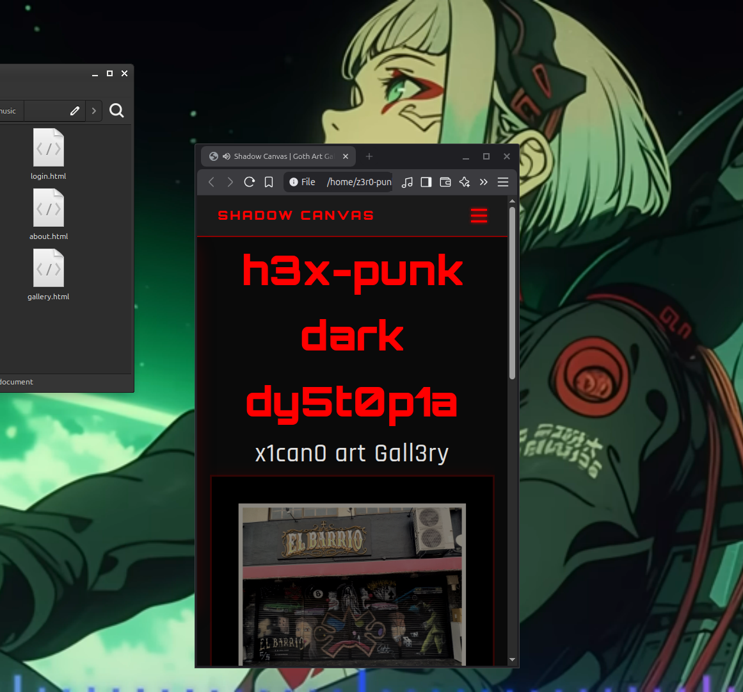

3.3
Added .gallery-item video and .video-caption styling to CSS for custom video players. Initially tried using TikTok's embedded code from my timelapse videos, but the embeds were too large and contained unnecessary UI elements that didn't fit the gallery aesthetic.
Created a videos/ folder within the project directory and downloaded five TikTok videos to host locally.
Encountered filename capitalization issues, two videos weren't displaying due to typos/case mismatches between HTML <source> tags and actual filenames. Corrected the errors and all five videos now play with native HTML5 controls.
While testing, noticed the Home page navbar was compressed and audio wasn't playing. Discovered I was working in the final_project_part2.3 folder instead of final_project_part3.2. The older folder was missing <audio> tags and had the outdated navbar structure. Copied the updated CSS and gallery files from 3.2 to restore functionality. Will rename working folder to 3.3 when complete
Fixed image sizing conflicts by adding unique class names (home-hero-img, about-img, contact-img) to each page's main image and creating specific CSS rules for independent size control (800px, 550px, 500px respectively). Removed cropping constraints from about page image. This also gives me better control over adjusting size of each image. I implemented !important so that the image specific CSS rules override any conflicting styles with sizing.

Yes still….!!!Reminder!!!: still need to adjust about and contact images. Find new track for Access Terminal and replace the temporary one.

Note: Realized there is no 3.3, will save for next week.

